Project Design Document

1. Design Intent
· What experience are you trying to create?
The experience we aim to create is a seamless and intuitive delivery service that users can control through a mobile app. The robotic delivery vehicle will operate autonomously, providing an efficient and reliable method for transporting small parcels.
· Who is it for?
This product is designed for anyone needing a simple solution for short-distance deliveries. It is particularly useful for people living in large apartment complexes, office buildings, or campuses where quick deliveries from one location to another are required.
· If solving a problem, what problem does it solve?
The robotic delivery vehicle solves the problem of inefficient short-distance parcel transportation. It reduces time and labour while ensuring packages are delivered swiftly without a lot of human effort. Additionally, it addresses safety concerns by using sensors to navigate and avoid obstacles.

2. Inspiration & References
- 1st Inspiration – Autonomous Delivery Robots in China
Delivery robots used in controlled environments such as hotels, restaurants, and airports served as the initial reference point. These systems efficiently navigate predefined indoor routes and enable contactless delivery.
Learnings:
  - Use of predefined pathways for controlled navigation within a space
  - The idea of replacing human effort in short-distance, repetitive delivery tasks
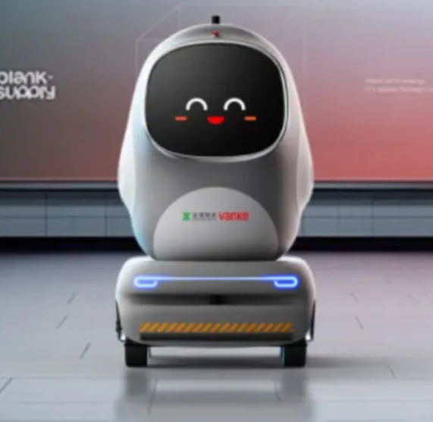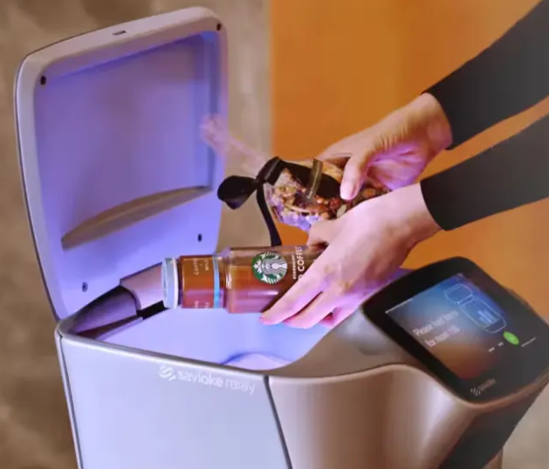
- 2nd Inspiration – Uber Eats Delivery Robots
These robots consist of storage boxes mounted on compact robotic vehicles, designed to transport food items along programmed routes. Pilot implementations in cities such as Philadelphia and Los Angeles provided practical real-world context.
Learnings:
  - The box-based storage system to accommodate items of different shapes and sizes within a fixed volume
  - Obstacle detection functionality for safer navigation
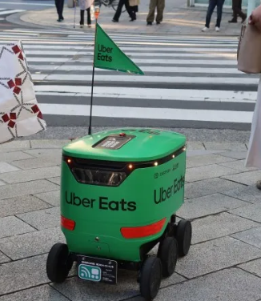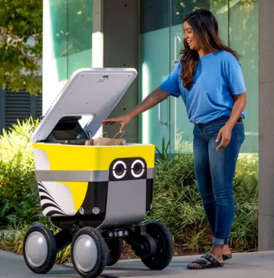
- Final Ideation and Development Support
To accurately understand and implement the system, online tutorials were referenced, particularly from Lee Curious.
Learnings:
  - Efficient arrangement idea for the working parts of the model.
  - Integration of ESP32, motor drivers, and sensors into a working model
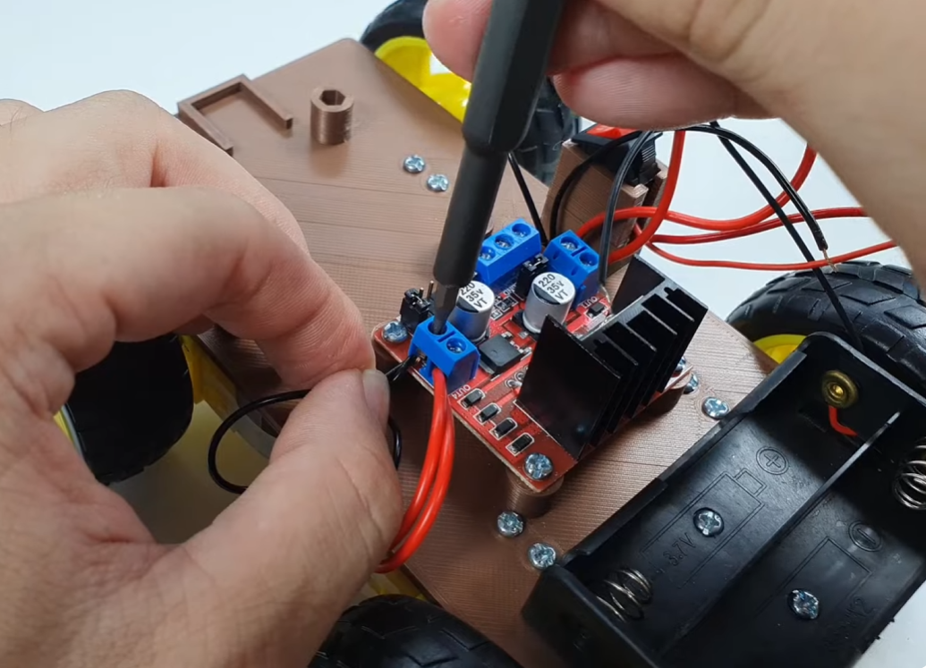

3. User Journey
Step-by-step experience of the user:
1. User starts…
The user opens the mobile application on their smartphone and connects to the robotic delivery vehicle via Bluetooth.

2. User interacts…
The user places their parcel inside the delivery box, and initiates the delivery process with a single tap.

3. System responds…
The delivery vehicle powers on and starts moving towards the selected destination. The ultrasonic sensor actively scans its surroundings, enabling it to detect and avoid obstacles along the way.

4. Success Criteria
Define measurable success:
· Functional
The robotic delivery vehicle should respond to user commands within 0.5 seconds of initiating a delivery. The ultrasonic sensor should detect obstacles and halt the vehicle's movement within 15 centimetres of an object.

· User experience
The mobile application should be intuitive and easy to use, with the delivery initiation process requiring no more than three taps.

· Reliability
The system should successfully complete the deliveries without manual intervention. The delivery vehicle is portable and so will operate on batteries.

5. System Overview
· High-level explanation of system
The robotic delivery vehicle consists of a four-wheeled chassis powered by independent DC motors controlled by an ESP32 microcontroller. The vehicle is equipped with ultrasonic sensors and a servo motor for obstacle detection. The system is powered by batteries, making it portable and ideal for indoor and outdoor use.

· What are the main parts?
  - Chassis: Four-wheeled base for movement.
  - Motors: Four DC motors to drive each wheel and one servo motor for ultrasonic sensor movement.
  - Microcontroller: ESP32 for processing and control.
  - Sensors: Ultrasonic sensors for obstacle detection.
  - Mobile Application: User interface for controlling the delivery vehicle.
  - Power Supply: Batteries providing necessary voltage for operation.
  - Servo Motor: For obstacle detection by the sensors along 180 degrees.

6. High-Level Block Diagram
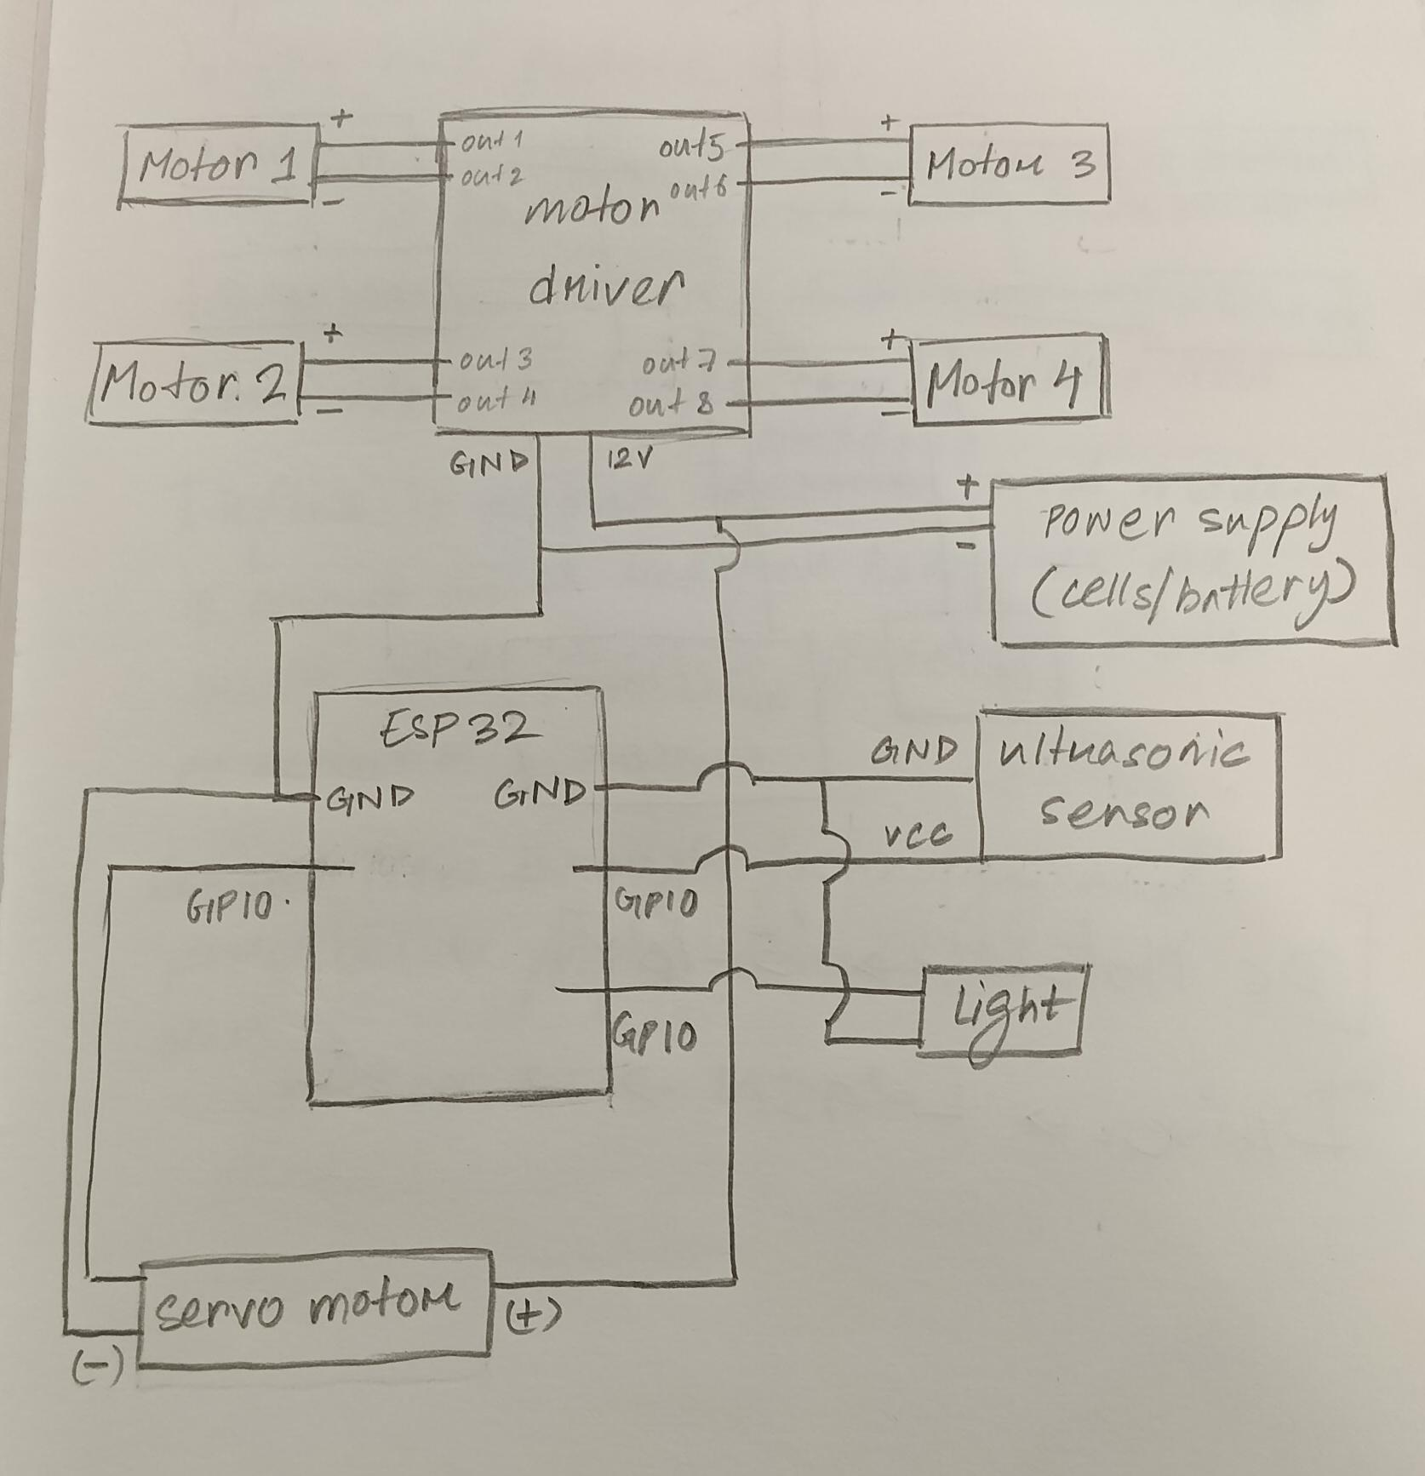

7. Input / Output Mapping
Input | Process | Output
- User selects a delivery path through a mobile application (via Bluetooth connection to ESP32)  - Parcel is placed inside the storage compartment at the starting point  - Pre-programmed route data stored in the ESP32  - Real-time distance data from ultrasonic sensors for obstacle detection  - Power supply input from 24V battery system | - ESP32 receives selected path command from the mobile application  - Microcontroller maps the chosen predefined route and initiates movement  - Motor driver regulates power distribution to individual DC motors  - DC motors drive the wheels to move the robot along the path  - Ultrasonic sensors continuously scan for obstacles  - If an obstacle is detected, ESP32 processes the data and alters movement (stop/redirect) to avoid collision  - System maintains navigation until the destination endpoint is reached | - Physical movement of the robot along the selected route  - Safe navigation with obstacle avoidance  - Successful delivery of the parcel from Point A to Point B  - Completion of the selected delivery path
8. Sketches & Concepts

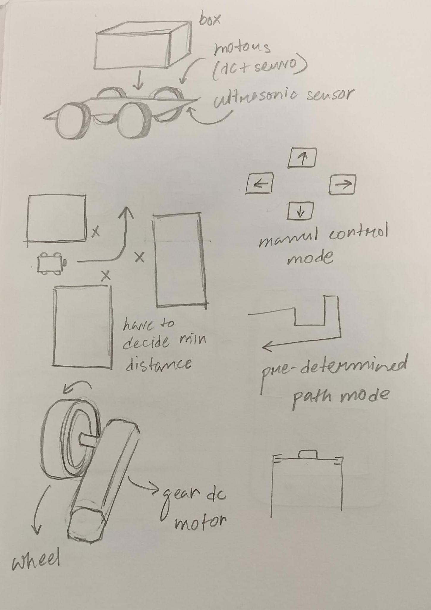

9. Final System Architecture (Labelled)
👉 Clear diagram showing all components and connections